Clase 13

ResNet20

Model version 1

Data_augmentation = True

Epoch 1/200
Learning rate: 0.001
1563/1563 [==============================] - 54s 35ms/step - loss: 1.5769 - accuracy: 0.4858 - val_loss: 1.7040 - val_accuracy: 0.5024
Epoch 2/200
Learning rate: 0.001
5/1563 [..............................] - ETA: 51s - loss: 1.3968 - accuracy: 0.5688
1563/1563 [==============================] - 50s 32ms/step - loss: 1.1858 - accuracy: 0.6377 - val_loss: 1.2261 - val_accuracy: 0.6223
–

Epoch 199/200
Learning rate: 5e-07
1563/1563 [==============================] - 49s 32ms/step - loss: 0.1673 - accuracy: 0.9851 - val_loss: 0.4386 - val_accuracy: 0.9175
Epoch 200/200
Learning rate: 5e-07
1563/1563 [==============================] - 49s 32ms/step - loss: 0.1665 - accuracy: 0.9860 - val_loss: 0.4389 - val_accuracy: 0.9174
Time for training: 9990.2261s
10000/10000 [==============================] - 3s 315us/step
Test loss: 0.43893712832927706
Test accuracy: 0.9174000024795532
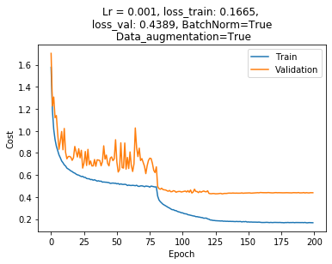
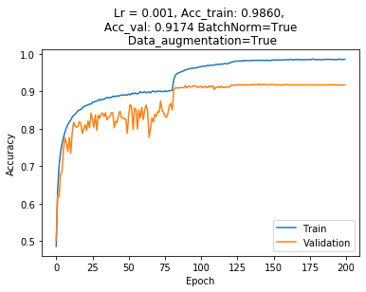

ResNet20

Model version 2

Data_augmentation = True

Epoch 1/200
Learning rate: 0.001
1563/1563 [==============================] - 74s 47ms/step - loss: 1.7497 - accuracy: 0.4911 - val_loss: 1.4811 - val_accuracy: 0.5723
Epoch 2/200
Learning rate: 0.001
3/1563 [..............................] - ETA: 1:08 - loss: 1.4648 - accuracy: 0.6042
1563/1563 [==============================] - 67s 43ms/step - loss: 1.3413 - accuracy: 0.6200 - val_loss: 1.3140 - val_accuracy: 0.6303

–

Epoch 199/200
Learning rate: 5e-07
1563/1563 [==============================] - 70s 45ms/step - loss: 0.1920 - accuracy: 0.9783 - val_loss: 0.4305 - val_accuracy: 0.9170
Epoch 200/200
Learning rate: 5e-07
1563/1563 [==============================] - 70s 45ms/step - loss: 0.1927 - accuracy: 0.9776 - val_loss: 0.4294 - val_accuracy: 0.9175
Time for training: 14072.5439s
10000/10000 [==============================] - 5s 522us/step
Test loss: 0.42942863879203796
Test accuracy: 0.9175000190734863

